Sathya Sai Center Of St.Thomas
Hurricane Relief Efforts Report
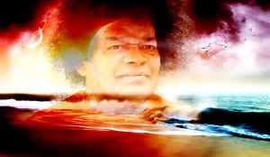

Our Love and Eternal gratitude to our beloved Swami who despite warning us years ago about maintaining balance between man and nature still carries us though the trials and tribulations for the fate we bestow upon ourselves by not respecting nature. We are blessed to have learned that in every experience and everything we go through there is a meaning of mercy. We are humbled to be given the opportunity to help a brother here and a sister there. Calamities can either make you or break you as Swamis children and as per his teachings through these projects we were able to see the divinity in all and realize that through Love and Service we are all “One”. It is sad that it takes such an event to make us realize our innate nature but incredible to acknowledge the strength given to us by the divine to be pillars for those around us. As Swami simply puts it “You and I are one.” Swami bless us with grace, wisdom, and selflessness so that we never ever forget we are here to serve mankind with nothing else but love love and more love.

Oct 14 2017
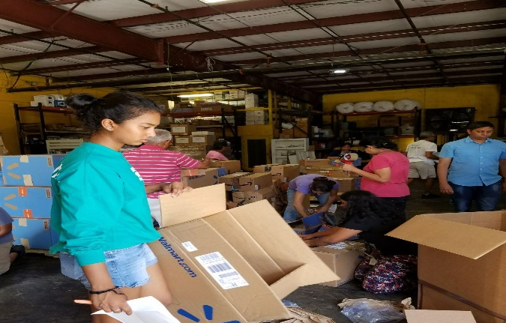
Sathya Sai volunteers gathered and packed 22 pallets of relief supplies to be sent to St.Thomas with the help of the United Way. The supplies came from different regions across the US and filled a 40-foot shipping container in West Palm Beach. The pallets contained food, water filters, batteries, flashlights, school supplies, cleaning supplies and other items. These products were transported it by ship to the island of St.Thomas arriving on 7th of November.

November 7th
The shipment arrived and was pending customs clearance. A meeting was held by the Satya Sai Center of St. Thomas, the United Way, and other organizations from the community to decide on what would be the most effective and fair way to distribute. We were blessed to be giving an amazing space at the India Associations Cultural Center to sort and kit the products. With love, support, advice, and guidance from the regional team a plan was set. The food and supplies were to be distributed to the needy over one week of continued service projects.
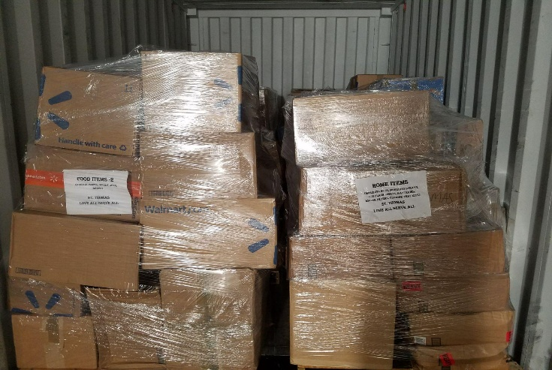
November 9th
The United Way cleared the shipment though customs and delivery was pending. Since the Hurricane the Cultural Center had no electricity and we would have to run on a generator. That evening city power was restored to the center. Swami and his divine games.
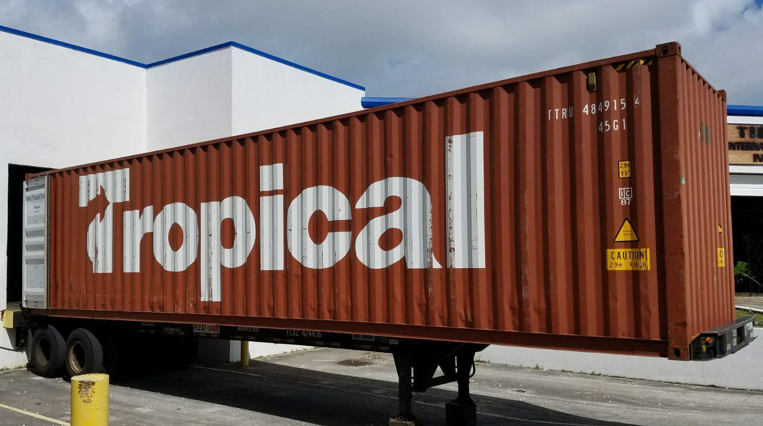

November 10th
Members of the United Way along with 15 USSO volunteers uploaded the trailer and trucked items to transport to the Cultural Center. The products arrive mid-morning and are sorted and separated according to type. Approximately 50 volunteers work for 2 days sorting separating and kitting supplies. Center members make sure all volunteers are fed and happy… energy levels are high.
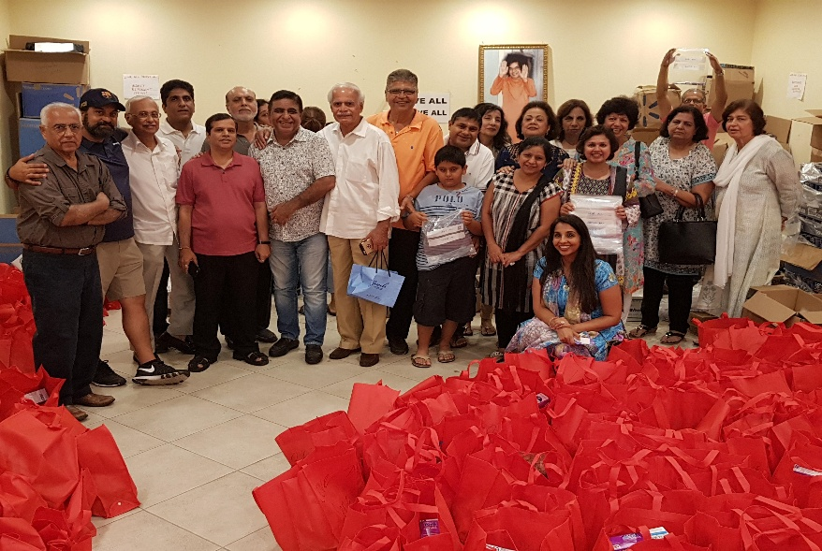
Several school students help with the project.

November 13TH
Distribution begins…
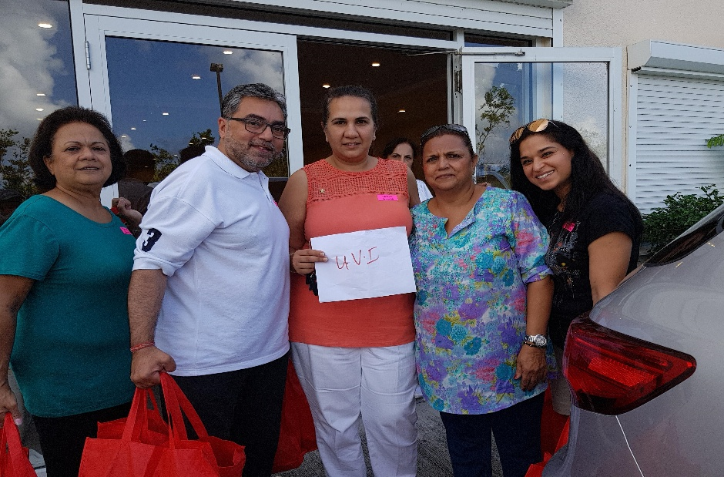
100 bags filled with supplies were brought to an office space at the university by volunteers and distributed to students at the University of the Virgin Islands.

At the same time a Pop Up distribution with a second set of volunteers take place. 80 people are served during this distribution.
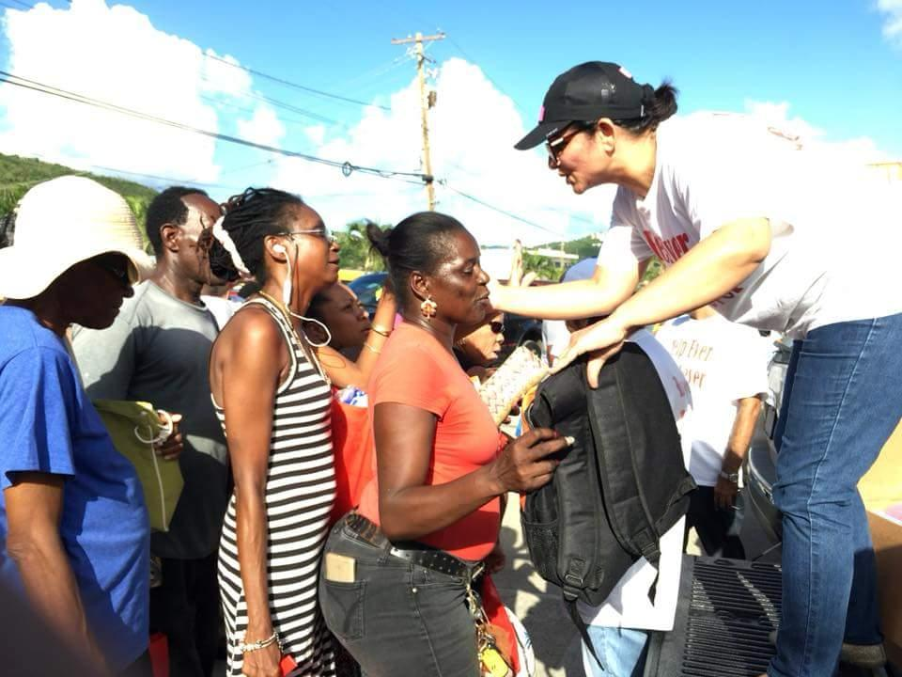
Later that afternoon another 100 people receive relief supplies though a drive through distribution.
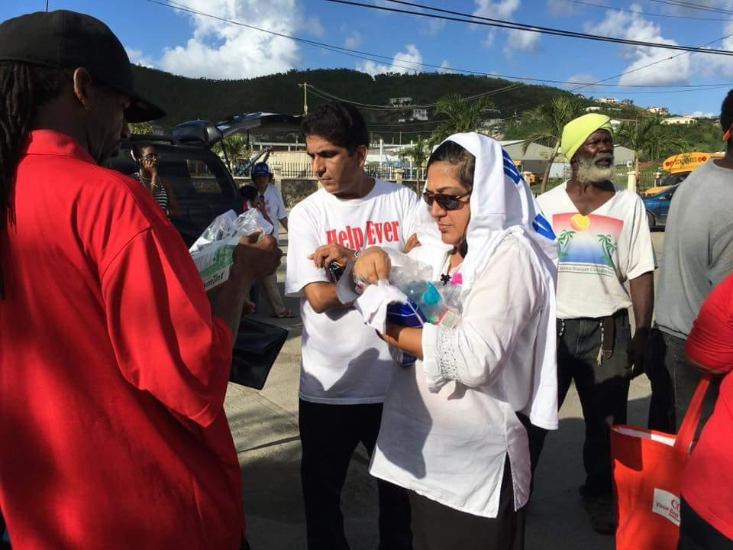
The same evening 8 seniors from the independent living facility receive a surprise visit from members and are given supplies.
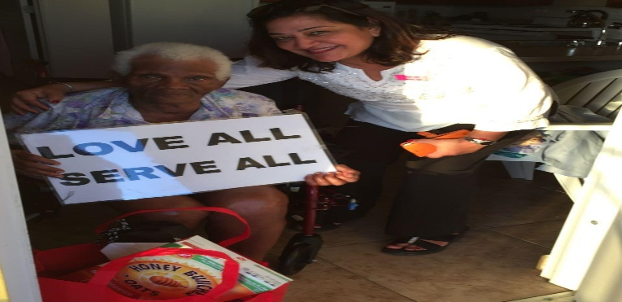
On this day we had volunteers from the nursing school at the university, The Red Cross, The United Way, and The India Association of the Virgin Islands.

November 14th
A staged distribution was set up with a DJ and the help of the United Way. A line for seniors, seating area for disabled, and a regular line was formed to efficiently distribute all item. There were various stations with different items and each. Every person received a ticket with 3 station numbers which they choose and the could go to and collect the items the tickets were then marked off to make sure no one took advantage and tried to receive twice. The event was well organized thanks to the partnership and advice of the United Way. Approximately 600 people received supplies on this day which was double of what we anticipated.
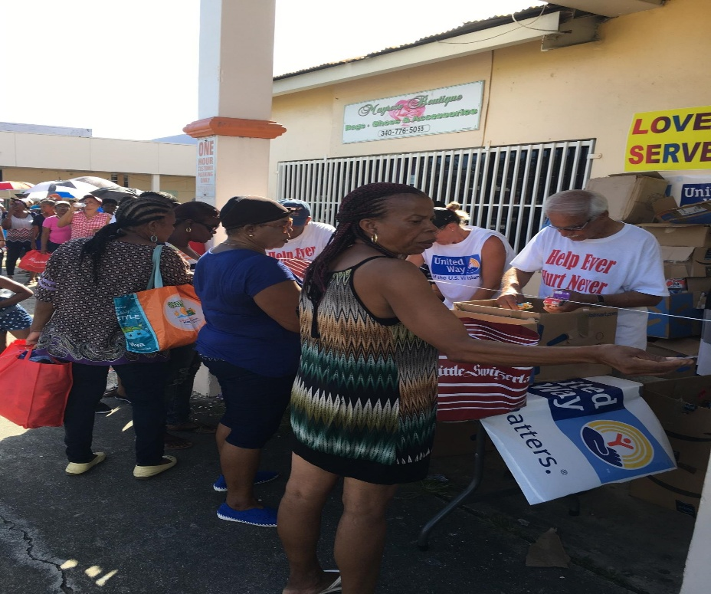
November 15th
On this Day the Queen Louise home, which is an elder shelter with approximately 35 residents, received several items such as powdered milk, cereals, detergents, filters, mosquito nets, and Clorox. These items were also used for the staff who had lost their homes. Nursing student from the University of the Virgin Islands volunteered to help install the filters and mosquito nets for these people.

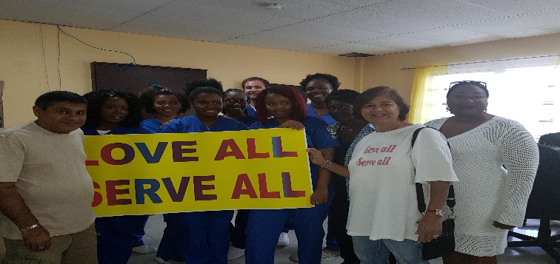

November 16th
Several boxes of Clorox and contractor's bags are distributed to all the public schools on St. Thomas. Bleach was not available on the island so many of the kitchens, bathrooms and classrooms were not clean enough for the children. The inspiration behind this was to let as many people benefit from the supplies which were so loving sent. For this project at least 2000 children benefited.
Members also receive bags for people whom they identified as needy approximately 100 bags are given.
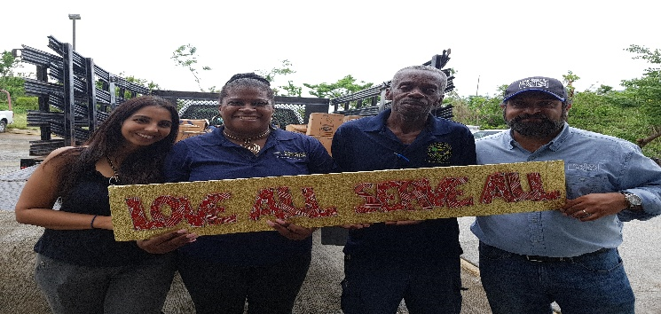
November 17th
Two distributions take place the first is a stall at a United way event where beans and batteries are given. The second a delivery is made to the salvation army with pasta, rice, and beans.
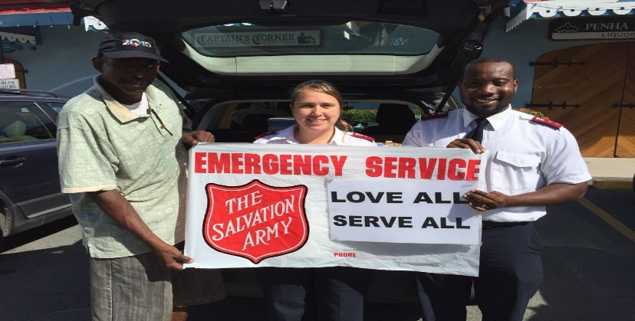

November 18th
To express our gratitude to the India Association Clorox, Contractor Bags, and Rice is gifted to the center.
November 19th
Monthly service project is organized with distribution of relief supplies to three homes one elder shelter, one children’s home, and one home for the disabled homeless. Cooked food along with a bingo game and supplies go to the elder shelter. The children’s home gets pizza with milk and supplies and the disabled home get cooked food with supplies . Approximately 25 volunteers help with this project. Approximately 55 people are served.
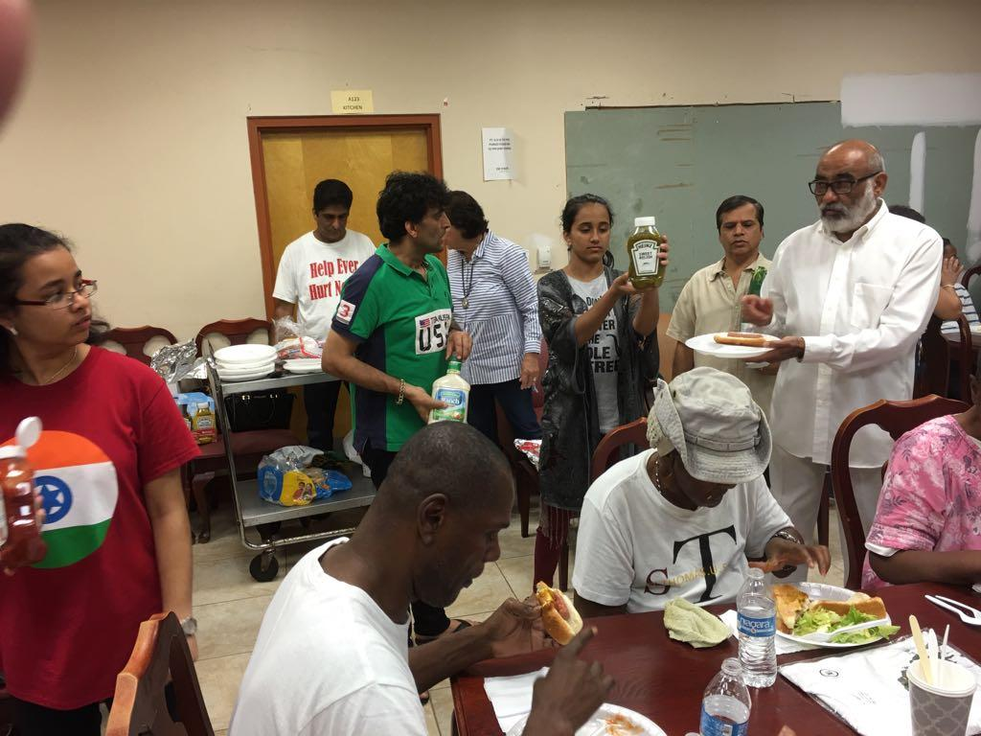
November 23rd
It amazing Swamis prasadam never ends. Rice is used cooked with other items to serve all whom attend Swami Birthday celebration. The center was expecting 125 people but close to 180 people attend.
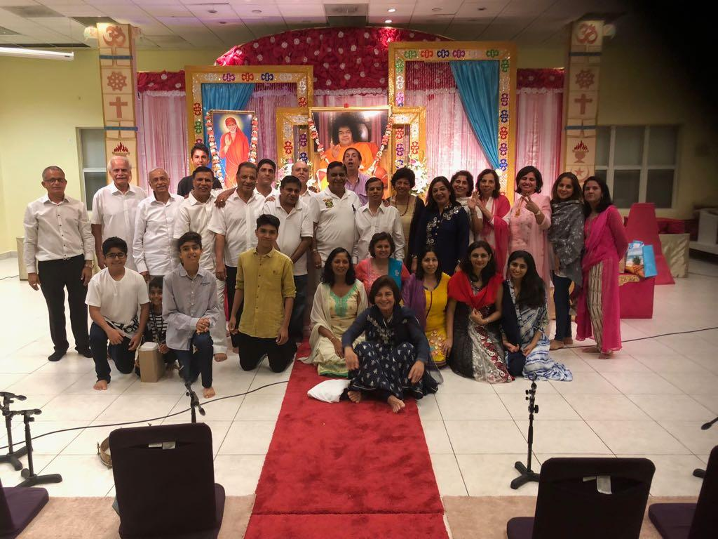

December 11th
Water bottles , socks, juices, water testing kits, and 90 school bags are given to Superintendent Dionne Wells Hedrington and Deputy Superintendent Racquel Berry Benjamin of the Department of Education. The items will be given to children who lost their homes for Christmas. The department of education asked us to attend event. So pictures of this will follow once it is complete.
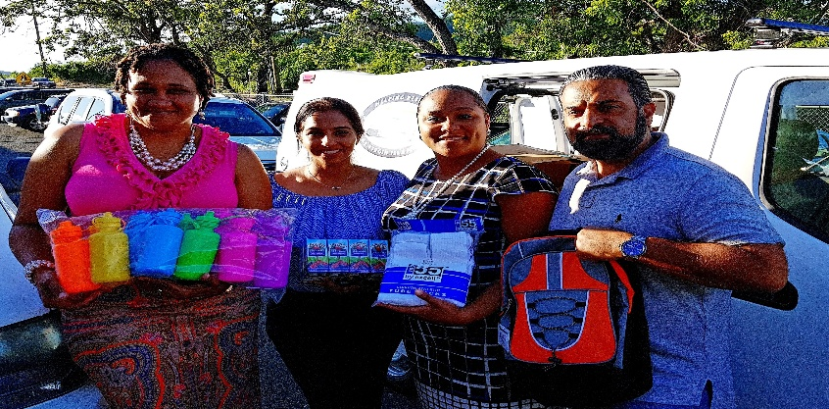

The St. Thomas center has kept some of the food supplies such as rice and oil to use for seva projects in the future. We thank all the regions and members who made his seva possible your love has reached the doorsteps of thousands affected in St. Thomas. A special thank you to our regional officers for your leadership, guidance, and love. Thank you Swami for giving us all the strength and opportunity to live in the present moment by doing so experiencing the divine not just talking about it.
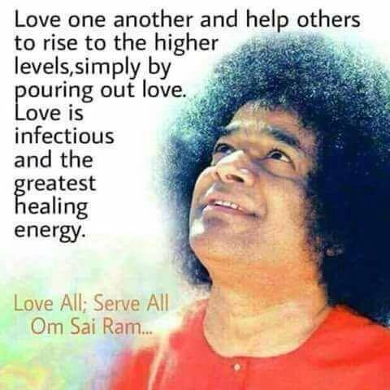
In Loving Service of Sai,
St. Thomas Sai Center
Sai Region 3, SSIO USA

